March 24, 2020

SUBJECT: CRITIAL EMPLOYEES & ESSENTIAL BUSINESSES EXEMPTED FROM EXEC. ORDER 20-08

To Whom It May Concern:
The person carrying this letter is employed by COMPANY NAME and is therefore exempt from the Governor’s Executive Order 20-08 to shelter in place, provided that they are travelling to and from work or engaged in another activity covered under one of the exclusions. “Section j” of the Order, as referenced below, specifically excludes “Critical Trades”, of which COMPANY is one.
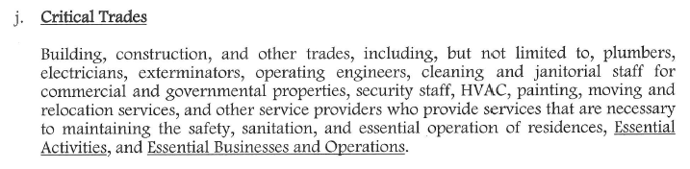
Should you need any further verification of employment, please contact me directly at xxx-xxx-xxxx.

Sincerely,

NAME AND TITLE

